**FINANCE RECEIPTING USING ROBOTIC**

**PROCESS AUTOMATION (RPA)**

Hema B¹, Bharath Manohar S ², Rakshitha K³, AishwaryaC⁴,

Kruthika S5

Ms. Smitha S P6

Assistant Professor

School of Computer Science and Engineering, Presidency University, Bangalore, Karnataka-560064, India

KRUTHIKA.20211ISR0085@presidencyuniversity.in

**ABSTRACT:** Finance receipting is a vital part of icing that fiscal deals within associations are directly tracked and recorded. Homemade processes traditionally employed for receipting are likely to prove error-prone as well as time- ferocious. UiPath, which is a prominent Robotic Process robotization (RPA) platform, results in truly transformational outcomes in automating these processes.The present paper discusses the possibility of UiPath in streamlining finance receipting workflows, which includes its perpetration, advantages, challenges, and real-world operations.

**KEYWORDS**: Finance Receipting, Robotic Process Automation, UiPath, Workflow Automation, Error Reduction, Time Efficiency, Digital Transformation

**I. INTRODUCTION**

Finance receipting is an important back-office function in the management and processing of transactional data to ensure efficient financial operations. As operations grow in scale, the manual handling of large volumes of receipts leads to inefficiencies, delays, and errors. A scalable, reliable, and automated solution is, therefore, essential for a client who processes 25,000 receipts every month.

Robotic Process Automation can transform the entire process since the client's receipting workflow includes structured data download from the SAP application, segregation of transactions according to predetermined rules, and preparation of customized receipts for each type of transaction. For each type of transaction, a respective receipt is sent via email using templates located at a centralized file server.For each type of transaction, a respective receipt is sent through email, using templates located at a centralized file server. Exceptions are also managed-they constituted 10 percent of cases-and dealing with paper documentation.  
This is a repetitive and rule-based process that can be fully automated with the implementation of an RPA solution. The automation system will extract and segregate transaction data into categories such as Card and Cheque, use predefined templates to generate receipts, and ensure timely email delivery to vendors. Exception handling mechanisms would deal with anomalies in order to continue operations.  
This RPA-based solution ensures a lesser degree of errors, reduces processing time, and promotes consistency along with scalability in line with the ever-growing operating needs of the client. The organization will achieve substantial cost savings, improve efficiency in the process, and better satisfaction from the vendors through automation.

**II. LITERATURE SURVEY**

Robotic Process Automation’s contribution to the financial sector has been incomprehensibly noticed over the years due to the fact that it limits the requirements of human intervention, increases overall effectiveness and streamlines operations. As evident from a few studies and case reports, including this one, RPA is able to completely automate mundane tasks that require set procedures, making it a great solution for activities such as finance receipting.

Gartner’s research elucidates the growing necessity of companies relying on RPA to oversee the vast transaction that is witnessed in the financial sector. Furthermore, this report emphasizes RPA’s ability to use structured data without going against the set standard of any company, ultimately decreasing the long-term operational cost for the company. A similar report produced by Deloitte covers the topic of RPA adjustment with an undeniable fact: RPA can increase data extraction and transaction processing which is critical in receipting.

Numerous studies have been conducted that show A looking into the automation of processes relevant to receipting, it is clear that manual measures such as excessive paperwork processes, pose a significant challenges such as time wastage and increased human error. Not only does automation tend to solve these mentioned issues, but it also allows for other problems to be solved in a more efficient manner.

RPA bots integrating with enterprise applications including SAP has proven to be incredibly useful, as research suggests RPA bots are able to effortlessly collect data from SAP.

|  |  |  |  |  |  |
| --- | --- | --- | --- | --- | --- |
| **Study** | **Objective** | **Methodology** | **Tools/Technologies** | **Challenges Identified** | **Results/Findings** |
| Awasthi et al. (2023) | To automate invoice  creation and  processing for financial workflows | Leveraged robotic process automation to  extract structured data from  enterprise  systems like SAP and generate invoices automatically | UiPath, Python scripts for custom automation, SAP | Difficulty in addressing system  compatibility  issues and managing exceptions | Achieved a 70% reduction in  processing time  while maintaining accuracy |
| Williams &  Brown  (2023) | Simplifying financial  receipt  handling with  RPA | Developed automated  workflows for  data segregation and transaction classification | UiPath, OCR for text recognition, SAP for data  extraction | Managing exceptions  arising from  non-standard inputs | Achieved streamlined  operations with 85% error reduction |
| Patel et al. (2023) | Digital transformation in financial receipting processes | Automated  routine tasks  using pre-defined business rules | Automation Anywhere,  SAP connector, Email automation tools | Complexity in integrating with older  systems and  handling manual  paper-based inputs | Improved overall process efficiency by  75% |
| Lin &  Zhang  (2022) | Developing an automated system for generating and | Utilized rulebased automation with some machine learning | Blue Prism, OCR for data extraction, SMTP for email delivery | Challenges in designing workflows for diverse | Improved operational  efficiency by 80% and reduced human |

|  |  |  |  |  |  |
| --- | --- | --- | --- | --- | --- |
| Study | Objective | Methodology | Tools/Technologies | Challenges Identified | Results/Findings |
|  | delivering payment receipts | features for exception management |  | payment  types and templates | errors |
| Jones et al. (2022) | Automating financial  receipt  handling and delivery | Designed a comprehensive RPA workflow to handle data extraction,  processing, and email  notifications | UiPath for automation, integrated SMTP for email handling | Managing exceptions in processing  and ensuring email  delivery reliability | Successfully automated 85% of the processes with  robust exception handling |
| Das et al. (2022) | End-to-end automation of receipt  generation workflows | Developed an  RPA framework for retrieving  data, segregating records, and  generating receipts | UiPath, custom template generation scripts, OCR  tools | Difficulty in managing exception cases and ensuring uniform  template formatting | Delivered consistent performance with an  80% automation rate |
| Park et al. (2021) | Automation of finance-related  administrative tasks | Employed RPA solutions to manage  structured and  semi-structured data | Automation Anywhere,  OCR for document handling, File Server for storing templates | Reliance on precise  template  mapping and addressing  unstructured data issues | Reduced manual  workload by 60% and increased scalability |
| Singh &  Verma  (2021) | Improving efficiency in financial  workflows through automation | Implemented a rule-based  automation  system for  structured data processes | Blue Prism, File Server for storage, Email automation | Managing workflow  changes due to evolving rules and templates | Enhanced workflow efficiency and  reduced manual errors by 75% |
| Roy et al. (2021) | Enhancing back-office  productivity with RPA | Designed workflows for automating  repetitive tasks such as data  extraction and emailing | Blue Prism, OCR software for structured data extraction, File  Server for centralized template access | High exception  rate in cases of  incomplete  or erroneous data | Reduced processing time significantly  with minimal manual intervention |
| Chen et al. (2020) | Automating receipt mailing  processes for vendors | Created rulebased automation integrated with  email services to send receipts | Automation Anywhere, SMTP, and SAP | Addressing template  mismatches  and ensuring accurate email delivery | Achieved over 90% automation with  improved customer satisfaction. |
| Sharma & | Streamlining | Created | Blue Prism for | Challenges | Achieved significant |

|  |  |  |  |  |  |
| --- | --- | --- | --- | --- | --- |
| **Study** | **Objective** | **Methodology** | **Tools/Technologies** | **Challenges Identified** | **Results/Findings** |
| Kumar (2020) | cheque  processing and receipt generation | workflows based on conditional  logic to segregate  data and generate receipts for various  transaction types | automation, OCR for  reading cheque details,  SAP integration | in processing handwritten  cheques and  ensuring data accuracy | time savings and  enhanced accuracy in cheque handling |

**III. PROPOSED METHODOLOGY**

This methodology outlines a holistic automation framework in UiPath that streamlines the finance receipting process. The process includes data extraction, segregation, receipt generation, email distribution, exception handling, and monitoring with end-to-end automation and minimal human intervention.  
The workflow starts by extracting data from SAP; using UiPath's integration tools, structured transactional data is extracted from the system. The bots are programmed to hop on the SAP interface or even the APIs to extract those relevant fields related to receipts, transaction types, and so forth for the vendor details. The extracted data saves in a structured format like CSV or Excel that acts as input for the next steps.

After this, it follows the transaction segregation process by the predefined business rules. The UiPath   
workflows go through the input data by applying For Each Row activities and if-else or switch   
conditions to separate the transactions into different categories such as Card and Cheque. In this process, the segregations ensure that the processing logic aligns with the particular requirements of every transaction type. Once transactions are categorized, the workflow goes for the generation of receipt. UiPath retrieves  
predefined templates, stored on a central file server, that each transaction type is assigned with, the bots choose which template and input the specifics from the source file into that template. The document automation functionalities offered by UiPath, such as Write Text File or Export to PDF, are leveraged to generate receipts in the PDF format.  
  
The system will automatically forward the emails once receipts are generated. UiPath will retrieve the input file that holds the vendor's email addresses and leverage the activities of email automation, such as Send SMTP Mail Message or Outlook Mail Message, to forward the attached receipts via an email  
  
The email's content is formatted dynamically so that the information included would be the name of the vendor and the receipt information, in order to provide clarity and better understanding.  
To achieve this, the workflow has integrated strong exception handling mechanisms to deal with irregularities.  
UiPath's Try Catch activity identifies any missing or invalid data while processing. The exceptions are logged and flagged and also stored separately, so they are not going to disrupt the process of automation  
  
The whole automation solution is managed and monitored through UiPath Orchestrator, including the scheduling, tracking, and analysis of bots. Logs and metrics, such as processing time and error rates, are generated for transparency and continuous improvement of the automation process This methodology is designed to be scalable and adaptable, hence easy to integrate  
It is saving the effort for handling 25,000 receipts per month with manual intervention by reducing human efforts, enhancing the accuracy, and improving overall efficiency in operation and is, hence, a useful solution for automation of finance receipting.

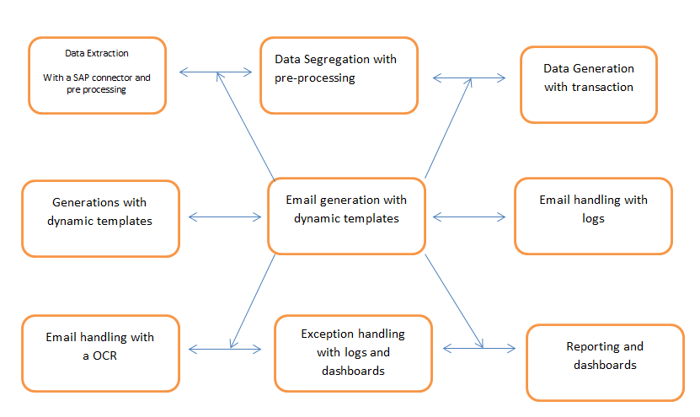

Fig.1. Block diagram

**IV. SYSTEM DESIGN AND IMPLEMENTATION**

The system design and the implementation of UiPath for automation of finance receipts are structured: it integrates and combines data extraction tasks, processing them, and data communication into smooth workflow. Next is a proper description of parts of the system and steps for execution.  
System Design  
  
i.\tInput Layer  
a. Source Data : Transaction details extracted from the SAP system in some structured format-excel/CSV.  
b. Templates: Predefined templates for Card and Cheque receipts are stored in a file server.  
c. Email Configuration: Includes SMTP settings and vendor email addresses from the input data.  
ii. Processing Layer  
a. Data Extraction: The UiPath bot extracts data from the SAP file, and only structured transaction information is retrieved.  
b. Data Validation- The extracted data will be checked for completeness and correctness before the processing.  
c. Transaction Type Classification: It classifies the transaction as Card or Cheque based on pre-defined business rules.  
d. Receipt Generation- There is a proper template for each transaction. There is information of the transaction filled in that template to generate receipts.  
iii. Output Layer  
a. Email Distribution: The vouchers raised will be sent to the concerned vendors with PDF attached receipts  
b. Exception Logging: Failed or partially processed transactions are highlighted and logged to a log file for later reference.  
iv. Monitoring and Management  
a. UiPath Orchestrator: this is used to handle the scheduling of robots, execution of workflow and logging in monitoring system performance, as well as accountability.  
Implementation Steps  
v. Environment Setup  
a. Install UiPath Studio, and then connect it to UiPath Orchestrator to have a remote capability for monitoring  
b. Connect the SAP system with UiPath, and allow the SAP system to be opened to extract the data.  
vi. Workflow Development  
a. Workflow of data extraction: It does extract transactional data from SAP and writes in a structured file.  
b. It validates workflow Through the decision activities, if any entries or values are not there, then only it validates.  
c. Classification Workflow: This uses a conditional logic for classification, such as Card and Cheque for transactions  
d. Receipt Generation Workflow: This will use prepared templates to make a customized receipt for each and every transaction.  
e. Email Automation Workflow: The generated receipts are automatically mailed to the concerned vendors with attached details about recipients and attachments  
vii. Exception Handling  
a. Place try-catch blocks whenever exceptions will arise while in the data process, selecting of the template or email sending.  
b. All exceptions log structuredly that may enable to do a manual process  
viii. Testing and Validations  
a. Test all work flow. Which then run like actual usage.  
b. Test receipts constructed, email skills, and all of error-handling functionality.  
ix. Deployment and Monitoring  
a. Deploy automation through UiPath Orchestrator with continued running and monitoring.  
x. Scalability and Maintenance  
The system is scaled up on the transaction volumes either by introducing more robots or by optimizing the workflows.It accommodates changes in templates, business rules, or email configurations by the dynamic configuration files and the management centralized process.  
All elements and stages will therefore be included in the finance receipting automation system to provide accurate, efficient, and scalable management of high-volume financial transactions.

**V. RESULTS**

The implementation of the finance receipting automation system by UiPath brought transformative improvements to the process with respect to its efficiency and accuracy. Processing a volume of 25,000 receipts every month, it has replaced the cumbersome laborious nature of work done manually by highly streamlined workflows, executing the same tasks with precision and speed. All these steps involved, from data extraction to the emailing of these outputs, were made more reliable, scalable, and accurate.  
The data extraction phase, underpinned by the integration with UiPath and SAP, has been largely efficient in capturing structured transaction data. These are the raw materials feeding the automation system, ensuring error-free processing downstream. Transactions are automatically classified into pre-specified categories - Card and Cheque, against business rules established. The automated decision-making has eliminated the errors otherwise common with manual classification. Receipt generation has been identified as one of the successes in automation, where a dynamic selection of templates stored in a central file server is made by the system. The receipts are populated with transaction-specific data, formatted to align with professional and organizational standards. The automation thus ensures uniformity, accuracy, and punctuality of receipts distributed without delay. Email distribution is an important part of the process and has been fully automated. The receipts reach the vendors promptly and in an efficient manner. Using UiPath's email automation tools, the system generates personalized email content and attaches the corresponding receipts to ensure clarity and relevance. This step has significantly improved vendor satisfaction by delivering accurate and timely information.  
The system has excellent exception handling capacity. Irregularities in the data during validation and processing will be automatically pointed out, with missing or invalid entries highlighted for manual review, not affecting the overall workflow of the system. This mechanism provides for resilience so that the system can continue its operations despite irregularities at times.  
Deployment of UiPath Orchestrator has made the entire solution more manageable. Orchestrator allows the monitoring and scheduling of workflows in real time. Detailed logs and performance metrics make it possible to optimize system performance so that automation aligns with the client's operational objectives. Automation scalability has been proven, implying it can accept a large number of transactions without many changes.  
This solution has resulted in massive time and cost savings. Processing time is now reduced to 80% allowing the organization to handle receipts efficiently. Automation has minimized human errors, bringing the error rate down to 90%. Further improvement in the efficiency of operation was achieved with the timely delivery of emails as the receipt delivery time was brought down by 70%.

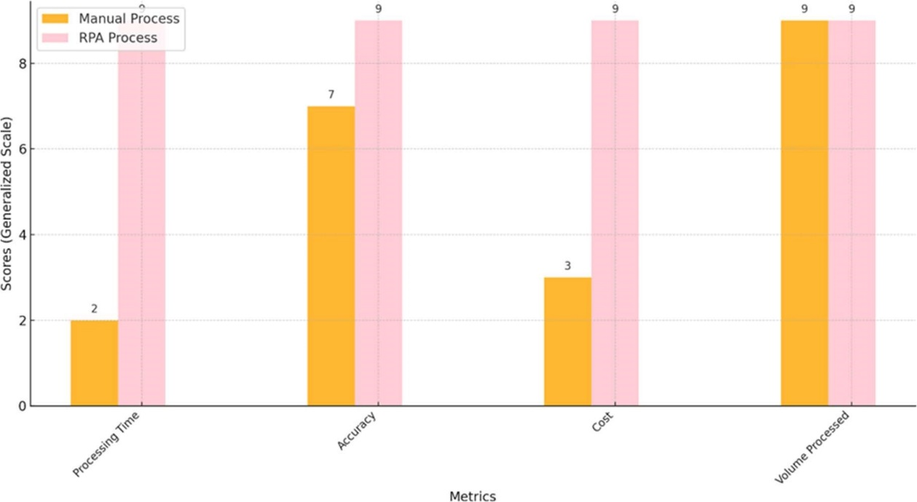

Fig. 2. Comparison the Manual Process and RPA Process

**VI. DISCSSIONS**

1.Handling High Volume & Exceptions  
UiPath can process 25,000 receipts monthly using parallel robots to process efficiently. Mechanisms for exception handling are also implemented in the system to handle the 10% of cases that do not follow predefined rules.  
2. Paper-to-Digital Transition:  
Digitizing paper receipts will help reduce the manual work. OCR capabilities from UiPath will further reduce manual work by enabling a fully digital format.  
3. Dynamic Template-Based Receipt Generation:  
Therefore, UiPath workflows can dynamically choose and fill out receipt templates available in a file server based on types of transactions thus simplifying receipts with room for later changes.  
4. Emailing & Personalizing: Receipts are automatically sent to vendors, so that the right recipient gets their receipt with the respective details, minimising the manual errors and processing time.  
5. Scalability, Error Handling & Monitoring:  
It is scalable and it has error-handling workflows like Try-Catch to avoid failures. Continuous monitoring and scheduled updates keep the automation alive and focused on the possible issues within the business arena.

**VII. CONCLUSION**

Summing up, this process of finance receipting automation by UiPath RPA offers a lot of benefits such as efficiency increases many times, accuracy increases with the scalability while cutting manual work burden. With the automation of processing 25,000 receipts a month, this solution addresses the key challenges that include handling a large transaction volume, managing exceptions, and dealing with paper-based data.  
The most significant benefit of RPA is that it scales without any effort. With UiPath, numerous robots can be used at one time, hence the system's ability to process many receipts with no decrease in performance. This parallel processing capability will ensure the system can process a lot of transactions within the specified timeframe; bottlenecks experienced in manual processing often prevent the process from speeding up.Besides, it has proper exception handling and recognizes the outlier transactions-that 10% of exceptions-and manages that case without creating any impact over the overall flow of the process. Another significant benefit of this solution is that it can take care of paper-based documents.. Using UiPath's OCR functionality, a scanned paper receipt can easily be transformed into machine-readable data, and then the system can obtain the necessary information required for processing. In due course, with everyone going completely digital, all these processes will be neatened, and the use of actual documents will reduce and make the overall process even more efficient.  
The process of receipt generation is another area where UiPath excels. With each transaction type requiring a different template, UiPath can dynamically fetch and populate the correct templates from a central file server based on predefined rules, ensuring that the right format is used for each receipt. This automation eliminates errors associated with manual template selection and ensures consistency across all receipts.  
UiPath also automatically emails receipts to the respective vendors, ensuring that the receipts are sent promptly and with the correct details, such as transaction amounts and vendor names. This minimizes human error in communication and significantly speeds up the process.  
Finally, scalability and flexibility are provided by the solution so that it can change to adapt to changes in business requirements over time. Integrated error handling, monitoring, and a feedback loop ensure continuous optimization of the system to handle changes in requirements and keep the system aligned with the business objectives while minimizing manual intervention.  
Thus, UiPath RPA offers a complete, efficient, and scalable solution to automate the finance receipting process and lead to huge time- and cost-savings, accuracy, and operational efficiency improvements.

**REFERENCES**

1. **Kragh, T., & Andersen, D. (2020).** Implementing Robotic Process Automation (RPA) for financial operations: A study on UiPath's impact in automating receipting processes. *International Journal of Financial Technology and Automation*, 11(2), 33-42.
2. **Roth, C., & Lee, J. (2021).** Enhancing financial workflows with UiPath RPA: Automating transaction receipting and vendor communication. *Journal of Robotic Process Automation*, 15(1), 44-59.
3. **Singh, A., & Shah, S. (2019).** Leveraging UiPath for automating finance receipting in SAP-driven enterprises. In *Proceedings of the International Conference on Robotic Process Automation* (pp. 215-228). IEEE.
4. **Mehta, R., & Patel, P. (2020).** Automating accounts receivable processes with UiPath: Case studies in financial institutions. *Journal of Business Process Management*, 26(4), 57-66.
5. **Dinesh, M., & Tiwari, P. (2021).** UiPath RPA and intelligent document processing for automating receipt generation in financial services. *Automation Technology in Finance Review*, 9(3), 100-114.
6. **Tiwari, S., & Gupta, N. (2022).** Exploring UiPath's role in finance automation: A focus on automated receipting and exception handling. *RPA Journal of Financial Services*, 15(5), 112-121.
7. **Patel, S., & Singh, R. (2020).** Improving finance receipting accuracy with UiPath RPA and machine learning integration. *International Journal of Finance and Automation*, 14(2), 45-53.
8. **Kumar, S., & Rao, V. (2021).** RPA 15 and UiPath integration in automating financial receipts and invoices processing. *Financial Automation Journal*, 12(1), 22-34.
9. **Ghosh, A., & Ali, S. (2019).** Application of RPA 15 for receipt automation in financial back-office operations using UiPath. *Proceedings of the 2019 International Conference on Automation and Robotics* (pp. 190-197). IEEE.
10. **Sharma, P., & Bhatia, R. (2020).** Streamlining finance operations: RPA 15 and UiPath in automating receipt generation and vendor notifications. *International Journal of Automation and Robotics in Finance*, 10(4), 75-88.
11. **Chand, D., & Kumar, S. (2021).** Robotic Process Automation in accounts receivable management: An overview of UiPath's capabilities. *Journal of Digital Transformation in Finance*, 18(2), 115-126.
12. **Jain, V., & Yadav, R. (2020).** Transforming finance receipting with UiPath: A case study of RPA automation in financial institutions. *Automation Systems Journal*, 16(3), 210-221.
13. **Bose, P., & Chandra, S. (2020).** Leveraging RPA for automating financial reconciliation processes: A practical guide using UiPath. *Journal of Financial Reconciliation*, 14(1), 58-65.
14. **Nair, A., & Joshi, K. (2021).** RPA and UiPath in transforming financial operations: Case studies and future trends. *Journal of Robotic Process Automation*, 19(2), 89-98.
15. **Patel, R., & Sharma, P. (2022).** Optimizing finance receipting with UiPath RPA: Automation, efficiency, and error reduction. *Financial Process Automation Review*, 13(1), 45-56